Pre-Calc
◄ Oct 2018 | November 2018 |  |  |  |  | Dec 2018 ►
Sun | Mon | Tue | Wed | Thu | Fri | Sat
 |  | Lesson 4.4  Pgs. 316-317 9-66 (x3) | Lesson  4.4 pgs. 317-318 67-95 | 1 Review  Pg. 361-365  1-35 odds | 2 Review  Pg. 364-365 37-83 odds | 3
4 Daylight Saving Time Ends  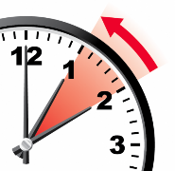 | 5  Chapter 4A  Test 4.1 to 4.4  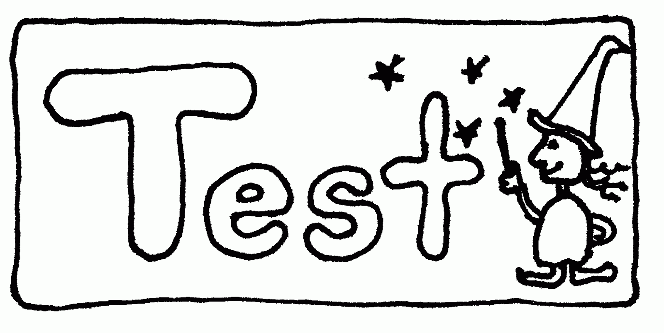 | 6 Election Day | 7  Lesson 4.5  Pg. 326  1-18 and  19-38odds | 8  In Class Activity  & Lesson 4.5 Cont.  Pgs. 326-327  39-59 odds | 9  Lesson 4.5 Cont.  Pgs. 327-329  61-87 odds  89 and 94 | 10  This Photo by Unknown Author is licensed under CC BY
11 Veterans Day | 12  Lesson 4.6A  Pg. 337  15, 17, 27, 31, 39, 43, 49,  And 51 | 13 Lesson 4.6B  Pg. 337 9-14 all, 19-25 odds, 29, 33, 35, 41  Quiz Review Activity/Worksheets  Lessons 4.5 and 4.6 | 14  In class Review  Graphing Trig. Functions  Pg. 326 #14, 16, 52, 58  Pg. 337 #22 ,32, 36, 38 | 15  In class Review  Graphing Trig. Functions | 16  Quiz  Lessons 4.5 & 4.6 | 17
18 | 19  Lesson 4.7 A  Page 347 1-3 all, 5-19, 21 odds, 23-39 odds | 20  Lesson 4.7B  Pgs. 347 43-75 odds, 105  and 110 | 21 | 22 Thanksgiving Day  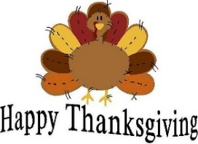 | 23 | 24
25  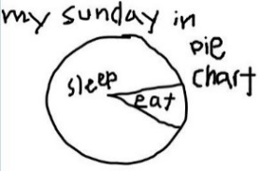 | 26  Lesson 4.8A  Pg. 357 5-23 odds | 27  Lesson 4.8B  Pg. 357 25-29 odds, 35-41 | 28 Bearing and Direction  Bearing Handout  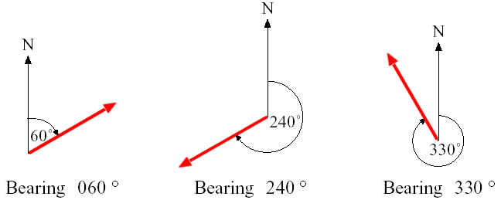 | 29  Review Pg. 365  89,91,95,101  105-117 odd  125-129 odd  139 | 30  4B Review | 4B Test Monday 12/3

