Pre-Calc. Forecast
◄ Dec 2017 | January 2018 |  |  |  |  | Feb 2018 ►
Sun | Mon | Tue | Wed | Thu | Fri | Sat
 | 1 New Year's Day | 2 | 3  Return From Winter Break  Trigonometry Inverses Worksheet  Hand Out Mid-Term Review  Time given in class to start working on review | 4  Lesson 5.4  Pg. 402  1-6; 7,9,12,15, 24, 27  and pg. 394  27,33, 35, 39 | 5 Cold Day No School  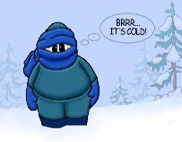  This Photo by Unknown Author is licensed under CC BY-NC-SA | 6
7  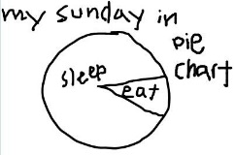 | 8  5.4 Cont.  31, 33, 39, 42 and  43-47 odds | 9  Chapter 5 Review | 10  Go Over Chapter 5 Review  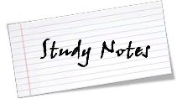  This Photo by Unknown Author is licensed under CC BY-SA | 11  Chapter 5 Test | 12  Sec. 6.1 Law of Sines  Pg. 434 1-4, 5-23 odds | 13
14 | 15 Martin Luther King  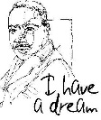 | 16  Sec. 6.1 Law of Sines  Cont. The Ambiguous Case (SSA)  Pgs. 434-435 25-49 odds | 17  Sec. 6.2  Law of Cosines  1-4; 5-31 odds | 18  Sec. 6.2 Cont.  Law of Cosines  33-47 odds | 19 Review Day | 20
21 | 22  Review Day  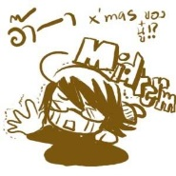 | 23  Exam Review | 24  Mid-Term Exams  1st and 2nd Hour | 25  Mid-Term Exams  3rd and 4th Hour | 26  Mid-Terms  5th and 6th Hour | 27
28 | 29  First Day Second Semester  Textbooks/ Activity/  classroom proceedures | 30  Sec. 6.3  Vectors in the Plane  Pg. 454  1-10; and 11-23 odds | 31  Sec. 6.3 Cont.  Vectors in the Plane  Pg. 454 25-30 all  31-47 Every other odd | 1 2 Groundhog Day  Sec. 6.3 Cont. Sec. 6.4  Vectors in the Plane Vector and Dot Products  Pg. 455-456 Pg. 465 1-4; 7-29 odds  79,81,83,85,86, and 88

