Acc. PreCalc. Forecast
◄ Jan 2018 | February 2018 |  |  |  |  | Mar 2018 ►
Sun | Mon | Tue | Wed | Thu | Fri | Sat
28 | 29 Classroom Expectations and Activity.  SAT #2 Practice | 30  SAT Practice #2 | 31  SAT Practice #2  Show vido on Pascals Triangle/sequence & Series | 1  Lesson 9.2 pg. 657 odds 5-49 | 2 Groundhog Day  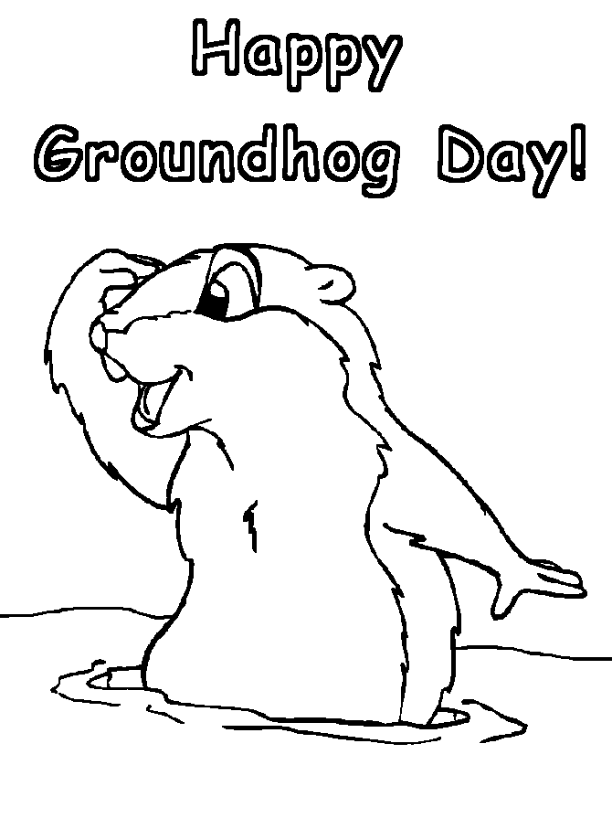  Lesson 9.2  Pg. 657  Odds 51-73, Odds 83-87 Odds 91-93 | 3
4 Super Bowl | 5  Lesson 9.3  Pg. 667 1-4, odds 29-55 | 6  Lesson 9.3  Pg. 668 odds 67-105, 115, 117, 133 | 7  Lesson 9.1  Pg. 647 1-5, E.O.O. 9-29, 67-70 | 8  Lesson 9.1  Pg. 647 1-5, E.O.O. 9-29, 67-70 | 9  Start Quiz Review  Lesson 9.1  Pg. 647 47-62, odds 85-95, 103-112 | 10
11 | 12 Lincoln’s Birthday  Formula Quiz  Quiz Review 9.1-9.3 | 13  Quiz 9.1-9.3  Start 9.4  Problems (K+1) | 14 Valentine's Day  Lesson 9.4 pg. 679 all 5-15, 17  This Photo by Unknown Author is licensed under CC BY-NC-SA | 15  Lesson 9.4 pg. 679  All 59-64 | 16  Math Art Project  (Need Computers)  Handout Rubric | 17  First Day Of Midwinter Break  This Photo by Unknown Author is licensed under CC BY-NC-ND
18 | 19  This Photo by Unknown Author is licensed under CC BY-NC  No School | 20  No School | 21 Int'l. Mother Language  No School | 22 Washington’s Birthday  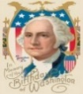  No School | 23  No School | 24
25 | 26  Lesson 9.5  Pg 686 all 5-19, EOO 21-37 | 27 Lesson 9.5  Pg 686 all 45-59, 73,75,85,87 | 28 Sequence Snoozing  Chapter Review  Pg. 714 | 3/1 3/2  Chapter Review Chapter 9 Test  Pg. 714  Odds 1-73, 83-95

